Spring JDBC Framework
- Developers sometimes struggle to describe what a database is. In one case, a database represents the actual data, and in other cases, it may represent a piece of software that manages the data, an instance of a process of this software, or even the physical machine that runs the manager process.
- Formally, a database is a collection of data; the database software (such as Oracle, PostgreSQL, MySQL, and so on) is called database management software or, more specifically, a relational database management system (RDBMS); the instance of RDBMS is called a database engine; and finally, the machine that runs the database engine is called the database server.
Exploring the JDBC Infrastructure:
- JDBC provides a standard way for Java applications to access data stored in a database.
- The core of the JDBC infrastructure is a driver that is specific to each database; it is this driver that allows Java code to access the database.
- Once a driver is loaded, it registers itself with a java.sql.DriverManager class. This class manages a list of drivers and provides static methods for establishing connections to the database.
- The DriverManager’s getConnection() method returns a driver-implemented java.sql.Connection interface.
- This interface allows you to run SQL statements against the database.
- The JDBC framework is quite complex and well-tested; however, with this complexity comes difficulty in development.
- The first level of complexity lies in making sure your code manages the connections to the database.
- Also, the number of concurrent connections is usually limited, and an excessive number of open connections slows down the database.
Spring JDBC Infrastructure:
- You can use Spring to manage the database connection for you by providing a bean that implements javax.sql.DataSource.
- The difference between a DataSource and a Connection is that a DataSource provides and manages Connections.
- DriverManagerDataSource (under the package org.springframework.jdbc.datasource) is the simplest implementation of a DataSource. By looking at the class name, you can guess that it simply calls the DriverManager to obtain a connection.
- The fact that DriverManagerDataSource doesn’t support database connection pooling makes this class unsuitable for anything other than testing.
Package hierarchy :
The Spring Framework’s JDBC abstraction framework consists of four different packages
1)core
2)datasource
3)object and
4)support.

- The org.springframework.jdbc.core package contains the JdbcTemplate class and its various callback interfaces, plus a variety of related classes. A subpackage named org.springframework.jdbc.core.namedparam contains the NamedParameterJdbcTemplate class and the related support classes.

- The org.springframework.jdbc.datasource package contains a utility class for easy DataSource access, and various simple DataSource implementations that can be used for testing and running unmodified JDBC code outside of a Java EE container.

- The org.springframework.jdbc.object package contains classes that represent RDBMS queries, updates, and stored procedures as thread-safe, reusable objects.

- The org.springframework.jdbc.support package provides SQLException translation functionality and some utility classes. Exceptions thrown during JDBC processing are translated to exceptions defined in the org.springframework.dao package.
- This means that code using the Spring JDBC abstraction layer does not need to implement JDBC or RDBMS-specific error handling. All translated exceptions are unchecked, which gives you the option of catching the exceptions from which you can recover while allowing other exceptions to be propagated to the caller.

DAO Pattern

- The primary purpose of DAO (Data Access Object) pattern is to separate persistence logic from business logic.
Problems of JDBC API
- We are using JDBC API as a low level data access API to implement the DAO classes. There are some disadvantages:
- Code duplication
- Resource leakage
- Error handling

- To solve the above problems we need to identify the parts of code that remains fixed and then encapsulate them into some reusable objects.

Introduction to Spring JDBC Framework

- The Spring JDBC framework takes care of retrieveing connection, preparing the statement, executing the query, handling transactions, handling exceptions and finally closing the connection.
- The services provided by Spring JDBC framework is shown in the table below. The table shows what actions Spring will take care of and which actions are the responsibilities of the application developer:
Action | Spring | Developer
Define connection parameters |  | X
Open the connection | X
Specify the SQL statement |  | X
Declare parameters and provide parameter values |  | X
Prepare and execute the statement | X
Set up the loop to iterate through the results (if any) | X
Do the work for each iteration |  | X
Process any exception | X
Handle transactions | X
Close the connection, statement and resultset | X

Working with DataSource

- We need a Connection object to perform any CRUD operation on a database. In Spring JDBC framework, the Connection objects are obtained through a javax.sql.DataSource (interface).
- Spring provides several options for making a DataSource available to the application.

Getting a DataSource from JNDI

<bean id = "dataSource"
class = "org.springframework.jndi.JndiObjectFactoryBean">
<property name = "jndiName" value = "java:comp/env/jdbc/myDataSource">
</bean>

Creating a DataSource Connection Pool provided by Spring

<bean id = "dataSource"
class = "org.springframework.jdbc.datasource.DriverManagerDataSource">
<property name = "driverClassName" value = "${jdbc.driverClassName}"/>
<property name = "url" value = "${jdbc.url}"/>
<property name = "username" value = "${jdbc.username}"/>
<property name = "password" value = "${jdbc.password}"/>
</bean>

Note: The DriverManagerDataSource is not meant for production applications.

Creating a DataSource Connection Pool provided by DBCP

<bean id = "dataSource" class = "org.apache.commons.dbcp.BasicDataSource">
<property name = "driver" value = "${jdbc.driver}"/>
<property name = "url" value = "${jdbc.url}"/>
<property name = "username" value = "${jdbc.username}"/>
<property name = "password" value = "${jdbc.password}"/>
</bean>

DBCP (Database Connection Pool)

- DBCP is provided by Apache, this contains interfaces and classes that take care of setting up the connection pool and DataSource object. The jars required are:
- commons-dbcp-1.4.jar
- commons-pool-1.6.jar
JdbcTemplate

- The JdbcTemplate is a central class of Spring JDBC framework which contains the most common logic like creation of connection, statement, query execution and closing connection.
- The JdbcTemplate class is used to execute all types of SQL statements and stored procedures.
- This class represents the core of Spring’s JDBC support.
- In the most simplistic view, you can classify the data definition and data manipulation statements.
- Data definition statements cover creating various database objects (tables, views, stored procedures, and so on).
- Data manipulation statements manipulate the data and can be classified as select and update statements.
- A select statement generally returns a set of rows; each row has the same set of columns. An update statement modifies the data in the database but does not return any results.
- The JdbcTemplate class instances are thread-safe.
- The JdbcTemplate also catches the SQLException and converts them to standard and more explanatory exceptions defined in org.springframework.dao package.
- The JdbcTemplate class is packaged into org.springframework.jdbc.core package. It is a non-abstract class and can be instantiated using any of the following constructors:

- public JdbcTemplate()

Construct a new JdbcTemplate object. This constructor is provided to allow Java Bean style of instantiation.

Note: The DataSource has to be set before using the instance.

- public JdbcTemplate(DataSource dataSource)

Construct a new JdbcTemplate object initializing it with the given DataSource to obtain connections for executing the queries.

Note: Spring JDBC framework internally uses JDBC API to perform CRUD operations on database server.
Methods in JdbcTemplate Class

- The JdbcTemplate class provides the following 3 types of methods to execute SQL queries on database server:
- update() – To execute DML queries
- queryForXxx() – To execute Select queries
- query() – To execute Select queries
- create() – To execute DDL queries
- call() – To execute Stored Procedures

Using JdbcTemplate to execute SQL DML Queries

- JdbcTemplate provides overloaded update() methods for executing single SQL DML query.
- It supports JDBC Statement and PreparedStatement style of executing the SQL DML queries.
- The mostly used update() methods in JdbcTemplate class are:
- public int update(String sql)
- Executes the given SQL DML query using JDBC Statement object.
- This method returns the update count describing the number of records affected.
- public int update(String sql, Object… args)
- Executes the given SQL DML query using JDBC PreparedStatement object.
- The “sql” string is a SQL DML query can contain bind parameters [?]. The variable arguments are used to pass values to bind parameters.
- This method returns the update count describing the number of records affected.

Using JdbcTemplate to execute SQL Select Queries using queryForXxx()

- JdbcTemplate provides overloaded queryForXxx() methods for executing single SQL select query.
- It supports JDBC Statement and PreparedStatement style of executing the SQL select queries.
- The mostly used queryForXxx() methods in JdbcTemplate class are:
- public Map queryForMap(String sql)
- public Map queryForMap(String sql, Object... args)
- public List queryForList(String sql)
- public List queryForList(String sql, Object... args)
- public Object queryForObject(String sql, Class requiredType)
- public Object queryForObject(String sql, Class requiredType,Object... args)
- public SqlRowSet queryForRowSet(String sql)
- public SqlRowSet queryForRowSet(String sql, Object... args)
Using JdbcTemplate to execute SQL Select Queries with query()

- JdbcTemplate provides simple ways to retrieve data from the database. This includes two simple steps described below:
- Prepare a SQL Select query and execute
- Read the results
- JdbcTemplate class includes overloaded query() methods to prepare and execute the SQL Select query.
- The Spring JDBC framework provides below callback interfaces to read the results after executing the SQL Select query using query() method:
- ResultSetExtractor
- RowMapper

ResultSetExtractor

- The ResultSetExtractor is a callback interface used by query() method of JdbcTemplate. This interface contains only one method with the signature shown below:

public T extractData(ResultSet rs) throws SQLException, DataAccessException

- The developer has to implement the extractData() method of ResultSetExtractor interface to provide code for extracting results from a ResultSet.
- The Spring framework will call extractData() method by passing ResultSet object after executing the select query.
RowMapper

- The RowMapper is another callback interface used by query() method of JdbcTemplate. This interface contains only one method with the signature shown below:

public T mapRow(ResultSet rs, int rowNum) throws SQLException

- The developer has to implement the mapRow() method of RowMapper interface to provide code to process each row of data in the ResultSet.
- The mapRow() method code should not call next() method on the ResultSet, it should contain code for extracting values of the current row.

Using JdbcTemplate to execute SQL DDL Queries

- JdbcTemplate provides overloaded execute() methods for executing single SQL DDL query. The signature of mostly used execute() method is shown below:

public void execute(String sql) throws DataAccessException

Using JdbcTemplate to execute Stored Procedures

- The Spring JDBC framework provides support for calling stored procedures. The call() method of JdbcTemplate is used to execute the stored procedure or function.
- The signature of call() method is shown below:
public Map<String, Object> call(CallableStatementCreator csc,
List<SqlParameter> declatedParameters)
throws DataAccessException
- The first argument of call() method is a CallableStatementCreator, which is a callback interface used by the JdbcTemplate to get the CallableStatement to execute.
- The CallableStatementCreator interface contains only one method and the signature of the method is shown below:
public CallableStatement createCallableStatement(Connection con)
throws SQLException
- The developer has to implement the createCallableStatement() method of CallableStatementCreator to create a CallableStatement using the given JDBC Connection object.
- The second argument of call() method is a java.util.List, which encapsulates the list of declared SqlParameter objects.
NamedParameterJdbcTemplate

- This is another kind of JDBC template class which enables executing queries where values are bound to named parameters in SQL, rather than indexed parameters.
- NamedParameterJdbcTemplate wraps a JdbcTemplate to provide more convenient usage with named parameters instead of traditional JDBC’s question mark [?] place holders.
- This provides better readability and ease of use when there are multiple parameters for a SQL statement.
Note: Similar to JdbcTemplate, NamedParameterJdbcTemplate class also provides update(), execute() and call() methods.

SimpleJdbcCall

- SimpleJdbcCall is a class provided by Spring JDBC framework to execute stored procedures and functions in a simpler way.
- The object of a SimpleJdbcCall is created by using below constructor
public SimpleJdbcCall(DataSource dataSource)

- Executing Stored Procedures
- Specify the name of store procedure by using withProcedureName() method of SimpleJdbcCall. The signature of withProcedureName() method is:
public SimpleJdbcCall withProcedureName(String procedureName)
- To execute the stored procedures use execute() method of SimpleJdbcCall. The signature of execute() method is:
public Map<String, Object> execute(Object… args)

- Executing Functions
- Specify the name of function by using withFunctionName() method of SimpleJdbcCall. The signature of withFunctionName() method is:
public SimpleJdbcCall withFunctionName(String functionName)
- To execute the function use execute() method of SimpleJdbcCall. The signature of execute() method is:
public Map<String, Object> execute(Object… args)

Transaction Management Overview

- Transactions allow grouping several operations into a single unit of work. A transaction can be:
- Started
- Ended by either
- Committing to write the data permanently to the database
- Rolling back to undo all changes that took place right from beginning of transaction

- If even a single operation within the transaction fails, all the previuos operations belonging to that transaction are rolled back and the unit of work simply terminates.

- For example:
- Let’s consider a typical transaction where an amount of Rs. 5000/- has to be transferred from Customer-A’s savings account to Customer-B’s saving account.
- From the banking perspective, this transaction looks like a single operation, but from the application’s perspective, it involves below two separate operations:
- Debiting Customer-A’s savings account by Rs. 5000/-
- Crediting Customer-B’s savings account by Rs. 5000/-
- If the debit operation succeeds, but the credit operation fails [or vice versa], the books of the bank will not balance at the end of the day.
- Hence, it is required to ensure that either both the operations succeed or both of them fail. This, thus, eliminates any inconsistency in the bank’s database as a whole.
- To achive this, Transactions are required.

- With the help of Transactions, multiple individual operations can be grouped together as a single individual transaction. This ensures that either all operations in that transaction are completed without errors or none of them.
Transaction Management in Spring

- The Spring Framework supports transaction management. Spring supports both declarative and programmatice transactions.

Note: Declarative transaction management is preferable over programmatic transaction management.

Spring’s Transaction Manager

- Spring framework uses different transaction managers based on the patform.
- The developer has to configure the required transaction manager in Spring XML file based on underlying API used for persistence.

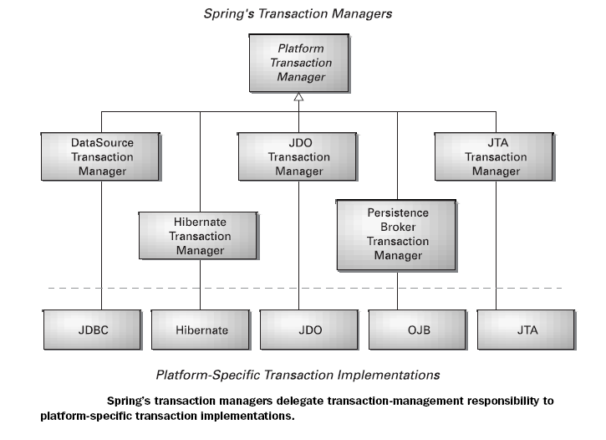
Using JDBC Transaction Manager

- If JDBC is used for the application’s persistence, DataSourceTransactionManager handles the transactions.

Using Hibernate Transaction Manager

- If Hibernate is used for the application’s persistence, HibernateTransactionManager handles the transactions.

@Transactional

- @Transactional annotation is used to declare transaction.
- @Transactional annotation can be used on any public method of bean or the bean itself.
- If the annotation is applied on the bean i.e. on the class level, every public method becomes transactional.
- Configure <tx:annotation-driven/> in Spring XML file to tell the Spring that transactions are annotation based.

Note: Thumb rule to use @Transactional annotation on the business logic methods i.e service methods and not on DAO methods.

Spring ORM Module

- The Spring Framework supports integration with Hibernate, Java Persistence API (JPA) and Java Data Objects (JDO) for resource management, data access object (DAO) implementations, and transaction strategies.
- For example, for Hibernate there is first-class support with several convenient IoC features that address many typical Hibernate integration issues.
- You can configure all of the supported features for O/R (object relational) mapping tools through Dependency Injection. They can participate in Spring’s resource and transaction management, and they comply with Spring’s generic transaction and DAO exception hierarchies.
- The recommended integration style is to code DAOs against plain Hibernate, JPA, and JDO APIs.
Configuring SessionFactory in Spring
- Natively, the main interface for working with Hibernate is org.hibernate.Session.
- The Session interface provides basic data-access functionality such as the ability to save, update, delete, and load objects from the database.
- Through the Hibernate Session, an application’s repository performs all of its persistence needs.
- The standard way to get a reference to a Hibernate Session object is through an implementation of Hibernate’s SessionFactory interface. Among other things, SessionFactory is responsible for opening, closing, and managing Hibernate Sessions.
- In Spring, the way to get a Hibernate SessionFactory is through one of Spring’s Hibernate session-factory beans.
- As of version 4.1, Spring comes with three sessionfactory beans to choose from: org.springframework.orm.hibernate3.LocalSessionFactoryBean
- org.springframework.orm.hibernate3.annotation.AnnotationSessionFactoryBean
- org.springframework.orm.hibernate4.LocalSessionFactoryBean
- org.springframework.orm.hibernate5.LocalSessionFactoryBean
- These session-factory beans are implementations of Spring’s FactoryBean interface that produce a Hibernate SessionFactory when wired into any property of type SessionFactory.
- This makes it possible to configure your Hibernate session factory alongside the other beans in your application’s Spring context.

- The developer has to configure LocalSessionFactoryBean class in Spring XML file as shown below:
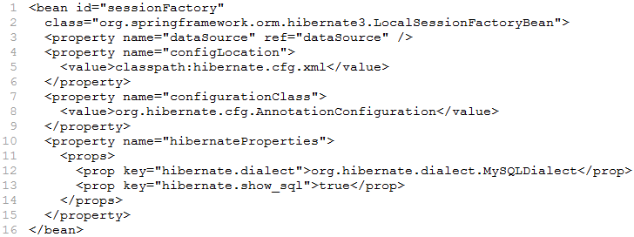

Configuring HibernateTransactionManager in Spring

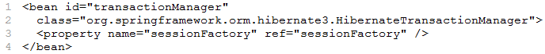

HibernateTemplate class
- The Spring framework provides HibernateTemplate class, so you don't need to follow so many steps like create Configuration, BuildSessionFactory, Session, beginning and committing transaction etc.
- The benefits of HibernateTemplate are:
- HibernateTemplate, which is a Spring Template class, can simplify the interactions with hibernate sessions.
- Various common functions are simplified into single method invocations.
- The sessions of hibernate are closed automatically
- The exceptions will be caught automatically, and converts them into runtime exceptions.
- HibernateTemplate was the way to work with Hibernate in a Spring application.
- Like its JDBC counterpart, Hibernate- Template took care of the intricacies of working with Hibernate by catching Hibernate-specific exceptions and rethrowing them as one of Spring’s unchecked data access exceptions.
- One of the responsibilities of HibernateTemplate is to manage Hibernate Sessions. This involves opening and closing sessions as well as ensuring one session per transaction.
- Without HibernateTemplate, you’d have no choice but to clutter your DAOs with boilerplate session management code.
- The mostly used methods of HibernateTemplate are,
- save(Object entity)
- update(Object entity)
- delete(Object entity)
- load(Object entity)
- get(Object entity)
- loadAll(Class c)
- bulkUpdate(String sql, Object... values)
- find(String hqlquery, Object... values)
- findByCriteria(Criteria criteria)
- findByNamedParam(String hqlquery, String[ ] paramNames, Object[] values)

- HibernateTemplate depends on SessionFactory, which is produced by LocalSessionFactoryBean.
<bean id=”ht” class=”org.springframework.orm.hibernate3.HibernateTemplate”>
<property name=”sessionFactory” ref=”sessionFactory”/>
</bean>

